A Message from our
Millbrook DECA

September Newsletter

Check Out our Website!
• • •
If you ever have any general questions or you need to see what events are coming up, the Millbrook DECA website is a great place to check out. The link for the site is millbrookdeca.weebly.com. On the front page of the site, you will see our social media page and Remind 101, which would both contain important information regarding different events happening in DECA. Other pages of the site contain information regarding our District, State and International competition and what to expect from your DECA Roleplay. Finally, our community service projects will be posted there and it will be important to check this regularly.

President

Hello Millbrook DECA members!
I’m so excited for this year and to get to know all of you! The international DECA theme for this year is Own Your Future! This is the first DECA newsletter of this year. I hope you’ve already checked out our website and social media sites. Below you’ll find bios from all of our wonderful officers this year. If you don’t know us already please introduce yourself! We are friendly, and of course please ask us if you have any questions about DECA. We have some fun events and community service projects planned for this year in addition to our weekly meetings. I hope you are all excited for our competitions and all we have planned for this year! Thanks for joining DECA!
Regards,
Jessica Tomlinson

Get to know your Millbrook DECA Officers!
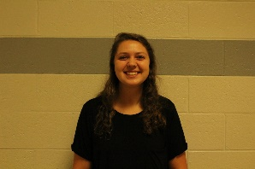
Jessica Tomlinson-President

Hey y’all, this year I am proud to be the president of our DECA chapter. I joined DECA my freshman year and this will be my fourth year in DECA. Last year I was the co-VP of Community Service. DECA has definitely given me the opportunity to improve important skills like interviewing and networking. Outside of DECA, I am Student Body Secretary, the “maniac mom” of the student section, a member of national honor society, math honor society, service club, and a senior in the IB programme. In addition I have a job as a hostess and expo at Piper’s Tavern. DECA has been so valuable to me during my time here at Millbrook so far.
  - Brandon Cashwell-VP of Public Relations
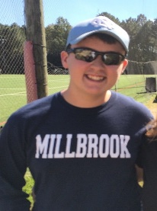
I joined DECA in my sophomore year of high school. A lot of my friends were joining the club and I just decided to tag along. After the first meeting I loved the idea of developing interviewing skills that could be used for different job opportunities and for applying to different colleges. This is my third year in DECA and I am the Co-Vice President of Public Relations. With DECA, I have been able to create different relationships with people inside of Millbrook DECA and the Millbrook community. Also, it has helped me understand the importance of teamwork and collaboration and why we need it in the workplace and in the society we live in. Besides DECA, I am the President of National Honors Society and a member of Spanish Club, Spanish Honors Society, and Millbrook Executive Board. Also, I will also be a Senior in the IB diploma programme. In my time away from school I am either doing tons of homework or working at Bruster’s.
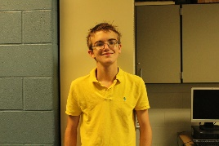
Max Roberts-VP of Public Relations
Hi everyone! I am a junior at Millbrook and I am very excited to be Vice President of Public Relations for our DECA chapter! My job is to help manage the website and our email, as well as help create newsletters to be sent out every month. I joined DECA my sophomore year and absolutely fell in love with it. DECA has allowed me to meet many amazing people and has also opened the door to many incredible opportunities. DECA is not just a "business club", it is a club that gives you valuable skills that can be used in pretty much anything you do. Outside of DECA, I am involved in Young Life. In my free time, I enjoy playing guitar, reading a good book, as well as writing stories. I look forward to seeing the amazing things that our chapter does this year!
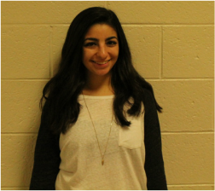
  - Loujain Al Samara-VP of Community Service
I am the co-Vice president of community service for the Millbrook chapter. I am a junior at Millbrook. I joined DECA last year as a sophomore, and in that year I learned that sometimes boundaries are meant to be broken so we can learn to love new things. In my first year, without much knowledge of what DECA was, I attended districts and placed as a finalist in the Principles of Business and Marketing category. This allowed me to discover my love for competition and marketing. DECA introduced me to a group of driven individuals. Since then I have joined the Millbrook Executive Board and become a leader in the creation of Tempest, Millbrook’s literary magazine. I am also a member of the Spanish honor society at Millbrook. This will be my second year in DECA, and I'm excited to see what this year brings.
Shaun Gillie-VP of Community Service
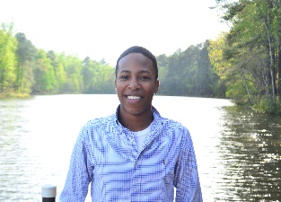
I have been a member of DECA for three years, and this year I am serving as the CO-VP of Community Service. I joined DECA because of my current DECA partner who shared her great experience of DECA with me. Last year, my partner and I medaled at States which allowed us to qualify for DECA’s International conference. Outside of DECA, I am a member of Millbrook Executive Board, Spanish Club, Service Club, and National Honor Society. Outside of school I work at Bruster's, travel, and play tennis. I'm looking forward to our chapter's involvement in community service as well as a successful competition season this year.
  - Sammy Storey-VP of Membership Activities
I am super excited to be your Co-VP of Membership Activities this year. I am a junior and it is my third year in DECA. I joined DECA because a few of my friends were joining and said that I should join too. I love seeing everyone all dressed up at competitions and getting to meet new people that have the same interests as me and that love DECA as much as I do. I am so excited to meet all of you. Outside of DECA I am on Millbrook Executive Board, in Latin club, I run cross country and I am a captain, and play soccer for Millbrook.
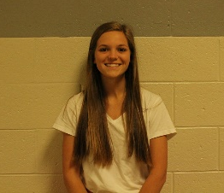
  - Izzy Morgan-VP of Membership Activities
I am so excited to be your co VP of Membership Activities this year. I joined DECA my freshmen year due to my sister’s recommendation. DECA has given me interview and leadership skills that I now use in my day to day life. I’ve met so many great people and have learned so much being a part of this club. I am now a junior at Millbrook. Along with DECA I am also a part of Millbrook Executive Board, Newspaper, and the Millbrook cross country team. When I am not at school I am most likely working at Chickfila.
  - Jonathan Underkoffler-VP of Promotion and Recruitment
I am the Co-Vice President of Promotion & Recruitment for our DECA chapter. I am a Junior and this is my third year of DECA. I joined my freshman year after a friend recommended it, and it turned out to be one of my favorite things at Millbrook. I love being a part of our DECA chapter, the traveling and competing with all the amazing people in our chapter makes DECA an amazing part of my life. Outside of DECA, I am involved in Millbrook Executive Board, Key Club, Drama Club, and Triangle Rowing Club. I can’t wait to have an amazing year travelling and competing alongside all of you!
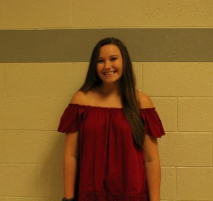
  - Emily Willis-VP of Promotion and Recruitment
This will be my third year in DECA and second year as an officer. I am the Co-VP of Promotion and Recruitment! I am a junior this year and I can't wait to meet everyone in our 2016-2017 DECA chapter! My favorite thing about DECA is meeting so many different people from other chapters around NC. DECA is a great way to learn interview skills and leadership that you use every day! Outside of DECA, I am a part of Key club, Spanish club, Photography club, Drama club and Newspaper. Outside of school you can catch me at every football game or at the nearest coffee shop!
  - Julia Vandermel-VP of Social Media
I have been involved in Millbrook's DECA Chapter since my freshman year. As a freshman, I qualified for the 2015 DECA International Career Development Conference and competed in Orlando, Florida. I am the Vice President of Social Media, which is a position that I have held since last year. Outside of DECA, I have served on the Millbrook Executive Board since my freshman year, and was voted Student Body Treasurer for this year. I also provide service to the French National Honors Society, French Club, Key Club, and World Cultures Club. I also played on the Millbrook Women's tennis team for two years. I have remained on all A honor roll throughout my years at Millbrook as well.

